Record a user's bid on an item, each new bid must be at a higher price than before.

Test 1: User tries to bid for CPU and the amount entered is less than 55.3. It requests the user to enter the value again and again.

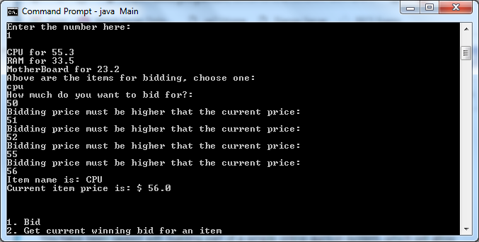

Test 2: User tries to bid for RAM and the amount entered is less than 33.5. It requests the user to enter the value again and again.

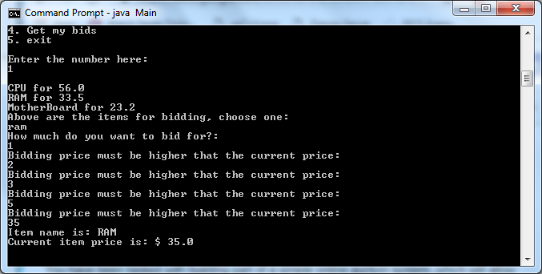

Test 3: User tries to bid for RAM and the amount entered is more than 33.5 in the first attempt. It accepts the user input value and updates the items current value.

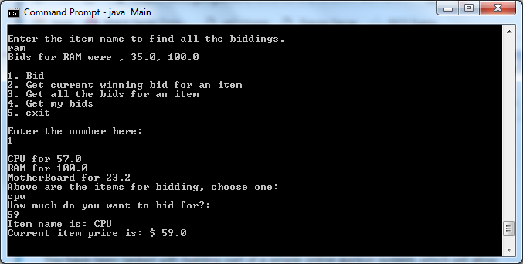

Get the current winning bid for an item.

Test 4: User tries to get the winning bid for an item. User enters a name that does not exist and returns a message to the user.

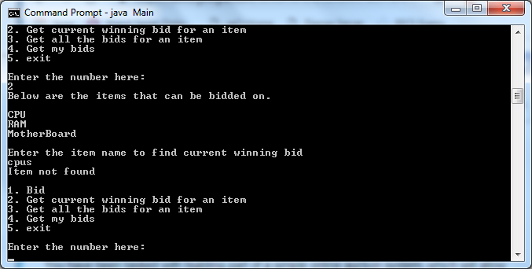

Test 5: User tries to get the winning bid for an item. User enters a name that does exist and returns the item name and the highest bidding.

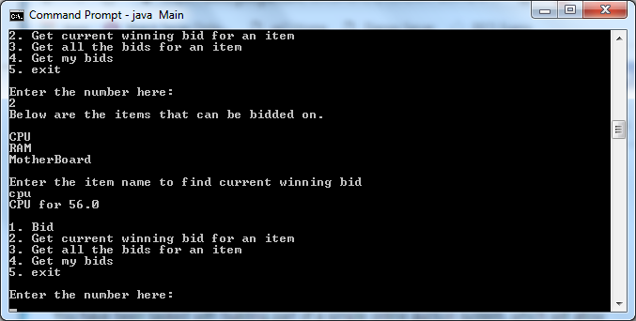

Test 6: User tries to get the winning bid for another item. User enters a name that does exist and returns the item name and the highest bidding.

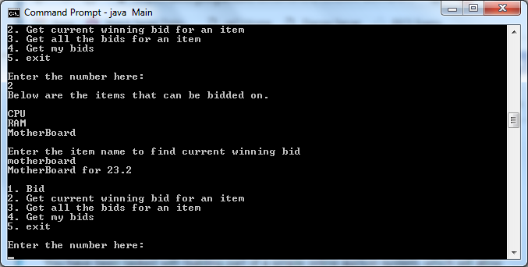

Get all the bids for an item

Test 7: User tries to get all the bids for an item. User enters a name that does exist and returns the item name and all the bidding records for the searched item in a single line.

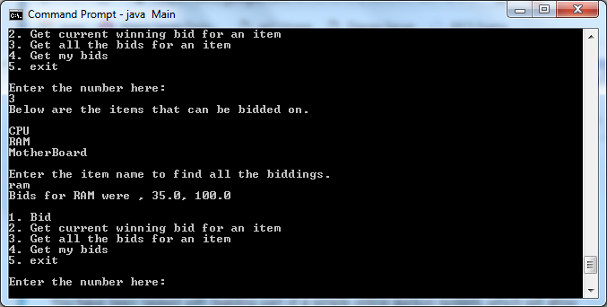

Test 8: User tries to get all the bids for another item. User enters a name that does exist and returns the item name and all the bidding records for the searched item in a single line. In this case there were no biddings for this item.

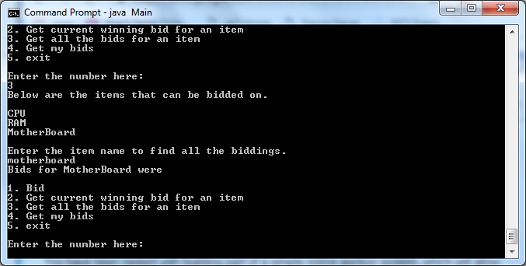

Get all the items on which a user has bid

Test 9: User tries to get all the items the user has bid on. Returns the item name and a list of floats (money).

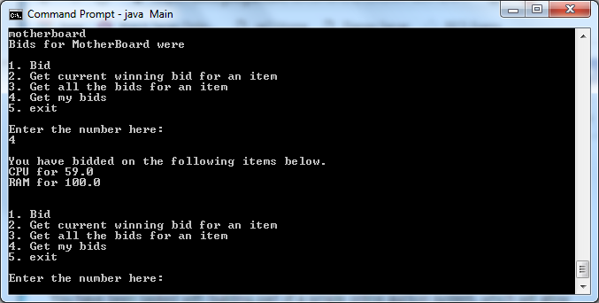

Test 10: User tries to get all the items the user has bid on. Returns none if the user did not bid on any items.

